**Meet the Teacher**

A big warm welcome to year 6. Year 6 is an important year as we get your children ready for their next big adventure of starting high school. Here is some information which you may find useful to navigate this year:

**Applying for Secondary School (Year 7)** – Applications for secondary school places open September – October 2022. The deadline to apply for a secondary school place is 31st October 2022. Information about this can be found by visiting:

[www.lancashire.gov.uk](http://www.lancashire.gov.uk) then by selecting ‘applying for a school place’

Over the next few weeks, the local secondary schools will be hosting open evenings. Keep checking on their websites and social media pages for any updates.

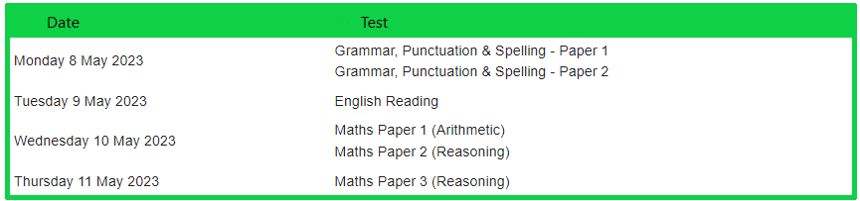**KS2 SATs** - At the end of year six, children are tested on the Maths and English syllabus for Key Stage Two (year 3-6) these are called KS2 SATS. Your child will sit 6 tests; 1 reading, 3 maths, 1 grammar and 1 spelling. These will be administered in the week beginning 8th May 2023. Please come to the welcome evening to see a variety of past SAT papers and ask any questions. Below is the timetable we will be following for KS2 SATs.

**Reading** – It is our expectation that children read a minimum of 3 nights per week for at least 20 minutes. Please use the reading diaries as communication if you have any queries. We aim to read 1:1 with the children every week, in addition to daily guided reading sessions. Children can change their reading books when needed and are asked to bring these in every day. Children also have a library slot each week where they can choose a book to read at home or during any free time.

**Spellings** – Your child will have weekly words (normally given out on a Friday with homework) which will be the focus for the week. These words will form part of a weekly spelling test every Friday. They will also be displayed on our class page on the school website and be available on Spelling Shed.

**Homework** – Homework will be given out (normally on a Friday) and will be expected back the following Friday. It will usually consist of; spellings, maths from the week, grammar and reading. There may be times when additional homework is sent out to support your child’s learning.

**Knowledge Organisers / Curriculum Maps** –Knowledge organisers will be sent out at the beginning of each term with key knowledge and vocabulary which your child will be learning. Curriculum Maps will also be sent out to inform you what your children will be learning in all lessons for the half term.

**Water Bottles** – Please ensure your child has a water bottle in school. I will be requesting that these return home every afternoon to be washed and refilled for the following day.

**P.E. Days/Kits** – This half term both of our PE sessions fall on the same day. We will be swimming and learning the skills of football on a Wednesday. Please ensure your child has the correct kit on for this day; white P.E. t-shirt, plain black or navy shorts/ leggings / jogging bottoms. After October half term, we will have P.E. on Monday and Wednesday.

Should you have any concerns or questions, please do not hesitate to contact me. You can phone the school office but the best way is via email: [n.gardiner@padihamgreen.lancs.sch.uk](mailto:n.gardiner@padihamgreen.lancs.sch.uk)